User Guide 12 Land Use Victoria Requisitions and Plan Amendments

Purpose of this User Guide
To provide information on how amendments to Subdivision Act and Transfer of Land Act (TLA) documents, such as a certified plan, plan of survey, abstract of field records, surveyors report, Supplementary Abstract of Field Records (SAFR) or compiled plan sheets are handled in SPEAR when Land Use Victoria requests changes after lodgment.

Who should read this?

Primary audience: Applicant Contacts, Responsible Authorities and Lodging Parties

Introduction
The amendment process for SPEAR plans in Land Use Victoria is carried out between the surveyor (Applicant Contact) and the plan examiner. Depending on the nature of the requisition, the plan examiner may request changes to the plan of subdivision, abstract of field records, surveyors report or compiled plan sheets. Plan amendments may be requested with Responsible Authority consent (or without consent).
In circumstances where a requisition is not applicable, the plan examiner can request application documents from the Applicant Contact, without changing the status of the application.
For ePlan applications, the plan examiner may also request changes to the ePlan, ePlan Validation Report or re-validation.
The amended documents then become the current versions and are accessible by all interested parties.
If the plan (or ePlan) requires re-certification, please refer to User Guide 9 Releasing documents for lodgement at Land Use Victoria.

12.1 General amendment process – Applicant Contact action
Land Use Victoria has the option to ‘Request Amendments to Applicant Documents’ before and/or after the plan has been lodged with Land Use Victoria. The examining officer can request amendments to the following document types:
  - Certified Plan
  - Plan of Survey
  - ePlan Validation Report (for ePlan-enabled applicant organisations only)
  - Abstract of Field Records
  - Supplementary Abstract of Field Records (SAFR)
  - Surveyors Report
  - Form 13 and SAFR declaration
  - Compiled Plan Sheets
  - Other – Request only
The details of the required amendments are made available through the Land Use Victoria section of the Details tab.
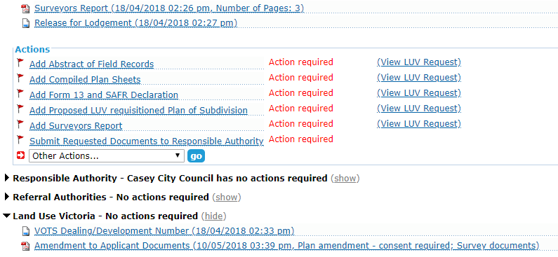SPEAR sends an email notification to the Applicant Contact organisation, as well as any users at that organisation who have the application marked as ‘watched’, advising them that there are requested changes. These actions will be displayed as mandatory actions (except for Other – Request only amendment requests).
The Applicant Contact must submit the amended document(s) in full; all pages of the requisitioned document must be re-submitted, even if the amendments made only apply to part of the document. This is important because Land Use Victoria will only use the amended version as the image source upon registration.
Amended documents must be authenticated with a password or digital signature (depending on the document type). Where digital signing was required, the amending surveyors name will be displayed in a new watermark on the document.
Once amended documents have been attached and authenticated in SPEAR, they will be shown in the Applicant Contact’s document list as shown:
Land Use Victoria may request multiple changes to these key documents at any point during the examination process. A similar requisition process is undertaken for TLA applications.
12.2 Amendments to the certified plan – Responsible Authority action
Depending on the requisition from Land Use Victoria, minor amendments to the plan may not require consent from the Responsible Authority. If this is the case, a SPEAR notification will be sent to the Responsible Authority advising them of the change.
If the amendment to the plan requires consent from the Responsible Authority a mandatory action will be placed (as shown below) to review the updated plan.
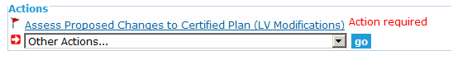

SPEAR sends a notification to the Responsible Authority advising of the required action.
By accepting the amendments, the Responsible Authority is consenting for Land Use Victoria to proceed with examination/registration.
If the amendments are accepted by the Responsible Authority, the amended plan becomes the new current plan on SPEAR and will be used as the image source by Land Use Victoria on registration.
If the Responsible Authority rejects the changes, a reason for the rejection must be provided. The certified plan then remains as before, and no further actions will appear. Alternatively, the Responsible Authority may reject the changes and request a re-certification. The Applicant Contact will then get an action to create a Form 8.
SPEAR will send a notification email to the surveyor advising them of the Responsible Authority’s decision to accept or reject the changes to the certified plan.
All parties benefit from this process as it ensures that the latest version of the plan is available in SPEAR.
The Applicant Contact is encouraged to contact Land Use Victoria and/or the Responsible Authority to ensure the desired outcome is achieved swiftly.

12.3 Amendments to the abstract of field records and surveyors report
Amendments to survey documentation do not get referred to the Responsible Authority for approval.
Once the latest version of the survey document with the relevant amendments is digitally signed by the surveyor and submitted to Land Use Victoria in SPEAR, those documents become the new current documents in SPEAR, and will be used as the image by Land Use Victoria on registration.
The surveyor should contact the relevant Land Use Victoria staff member to advise them that the required changes have been made and that examination can proceed.
This function may also be used to prompt the surveyor to supply survey documents where they had previously not been supplied (i.e. if a plan does not meet the non-survey guidelines).
12.4 Amendments to an ePlan application

NOTE: This section is for ePlan applications only.
There are various amendment options that Land Use Victoria may use to request ePlan changes, and may include:
Request amendment to the ePlan (same as amendment to the plan)
Request annotation of the Validation Report
Request revalidation of ePlan
Revalidation of ePlan may be requested when a new version of the Validator has been released, and Land Use Victoria request the ePlan be validated using the new version.

12.5 Amendments to the compiled plan sheets
Amendments to compiled plan sheets can be requested by Land Use Victoria at any time prior to registration.
Once the new version of the compiled plan sheets, with the relevant amendments has been authenticated by the surveyor, those documents become the new current documents on SPEAR and will be used by Land Use Victoria for compilation purposes.

12.6 Amendments to lodging party documents
Land Use Victoria may request extra supporting documents or amendments to documents supplied by the lodging party. The lodging party will be notified by email of these requests.

12.7 Amendments to other documents – Request only
Land Use Victoria can request documents from the Applicant Contact, without affecting the status of the application.
A plan examiner may request other information (for example, a road abuttal justification) by selecting the ‘Request Only’ option. Once the request has been entered, the Applicant Contact will receive an email notification of the request.

Need more information?
To get further information on this topic can be found by:
- Contacting the staff in the Subdivisions Branch at Land Use Victoria
- Visiting the SPEAR website www.spear.land.vic.gov.au/SPEAR/
- Contacting the SPEAR Service Desk on 9194 6012 or email spear.info@delwp.vic.gov.au

